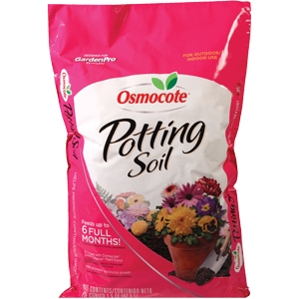

Osmocote Potting Soil
- 1.5 Cubic Feet
- Enriched with plant food
#11
- Feeds up to 6 months

$12.99
7269459

